1. Arrival time of te Wireshark ICMP traffic:

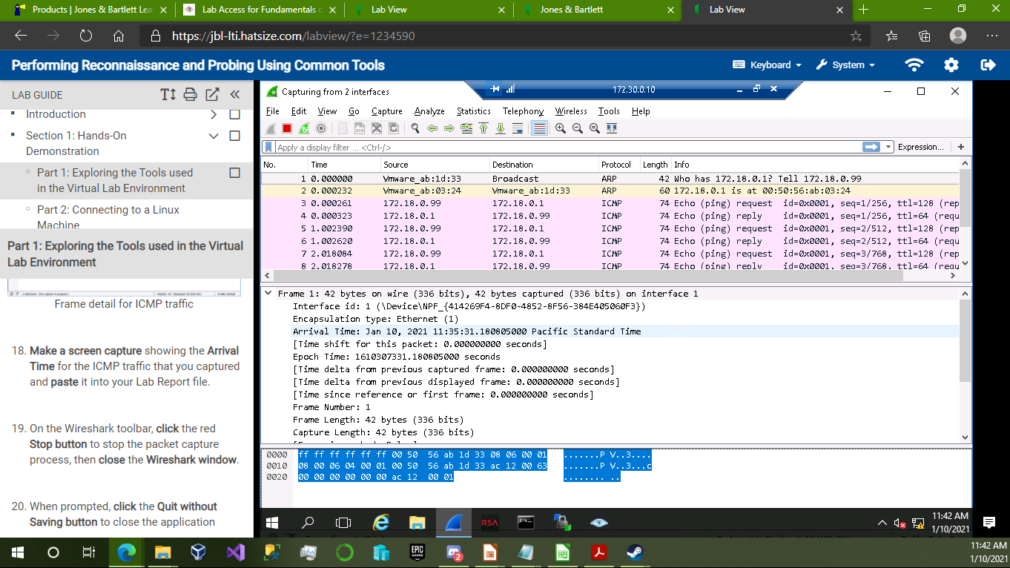

2. Filename of the attachment in the NetWitness Investigator Demo Collection:

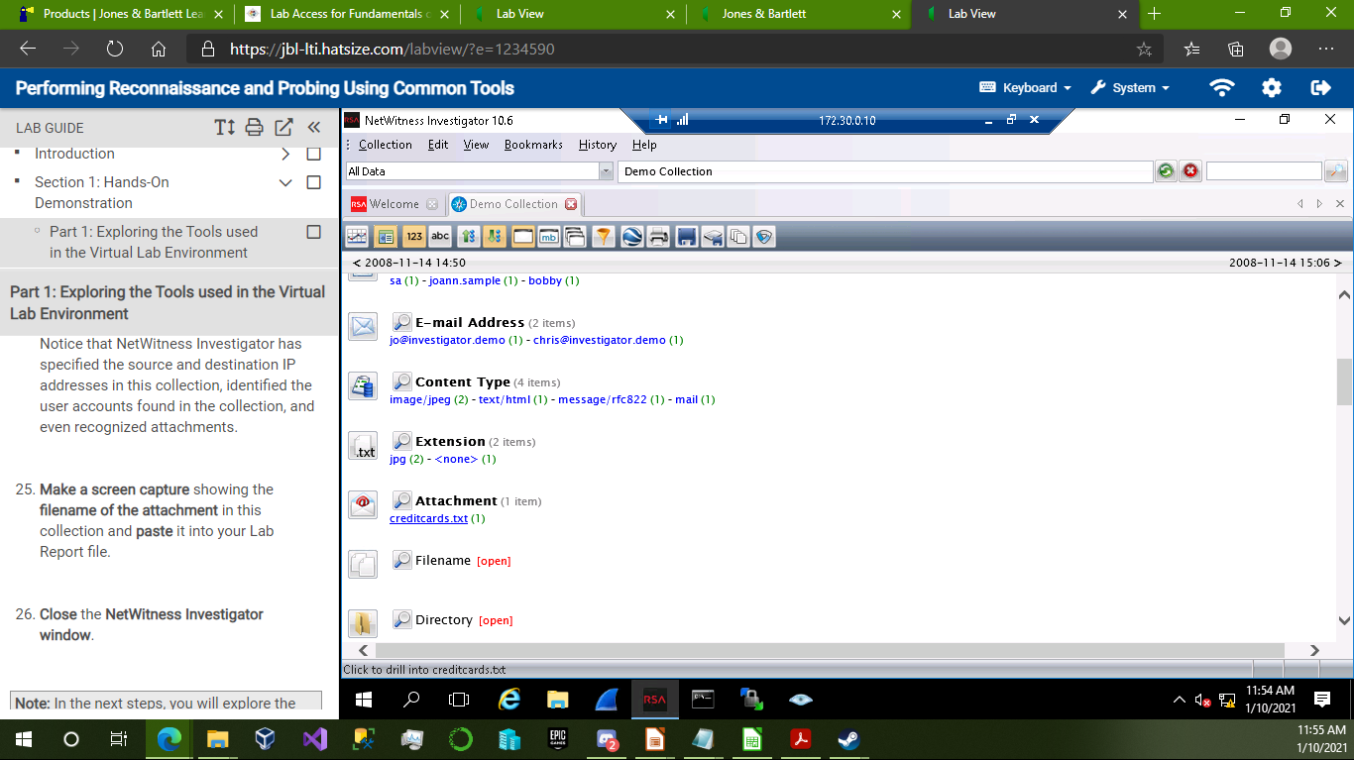

3. Fisheye Bubble Chart from Zenmap scan:

